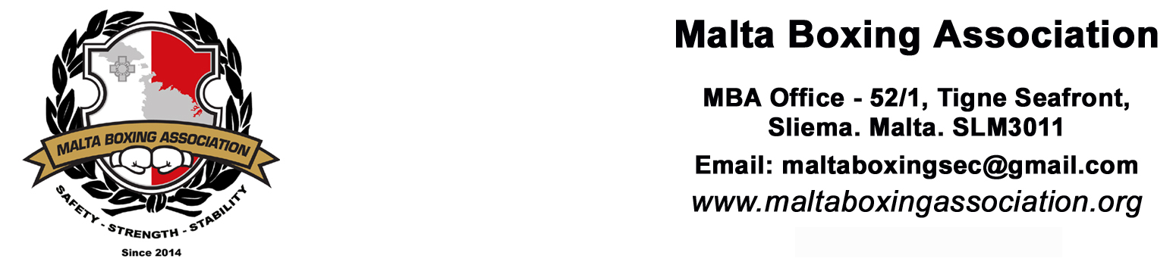BOXING PROMOTER / MANAGER / COACH / SECOND / MATCHMAKER
APPLICATION FORM
DATE OF APPLICATION
FIRST NAME
SURNAME
GENDER | MALE |  |  |  | FEMALE
DATE OF BIRTH
ADDRESS
 | POSTCODE:
PHONE NUMBER/S
EMAIL
I.D CARD / PASSPORT | (Photocopy is required)
A COPY OF THE POLICE CONDUCT MUST BE ATTACHED WITH THIS FORM
APPLICATION FOR: |  | PLEASE TICK WERE APPLICABLE
PROMOTER + MATCHMAKER |  | €500.00 |  | COACH* |  | €75.00
MANAGER |  | €150.00 |  | MANAGER + COACH* |  | €200.00
SECOND* |  | €25.00 |  | MATCHMAKER |  | €150.00
TOTAL €: |  |  |  | Total €:
Cheques should be made payable to: Malta Boxing Association
*FIRST AID COURSE – DATE OF CERTIFICATION |  |  |  | / / - Please attach copy of certificate
MBA License holders are to abide by the Rules & Regulations of the Malta Boxing Association as laid down in the Statute which can be accessed and downloaded at: https://www.maltaboxingassociation.org/rules--regulations.html
For office use only:
Date Received: |  |  |  |  | Mem. No.:
Approved: | YES |  | NO
Documents attached | ID CARD | PASSPORT |  | POLICE CONDUCT |  |  | FIRST AID
Signature of Secretary or Technical Officer |  |  |  |  | Stamp

